**Image Classification**

Of Shark Tank Cast

**Final Project (Fall 2022)**

**Subject:** Machine Learning

**Guided by:** Professor. Travis Milburn

**Presented by:** Maryam Merchant

**What will I do?**

Given images of Shark tank Cast I will tell the name of person based on images.

**Mark Cuban**

**Lori Greiner**

**Tools:**

* Python Libraries: Pandas, Scikit-learn
* Open CV

**Dataset:**

My dataset consists of 5 different Shark Tank image judges and I have downloaded the data from Google using Fatkun Chrome extension which is used to batch download the image from the current tab.

So, I have 5 folders which consist of images five Shark Tank judges named:

* Mark Cuban
* Lori Greiner
* Kevin O'Leary
* Barbara Corcoran
* Robert Herjavec

**Read the image: Using Open CV**

**Then will use Open CV Har cascade library to detect the face and eyes of the image**

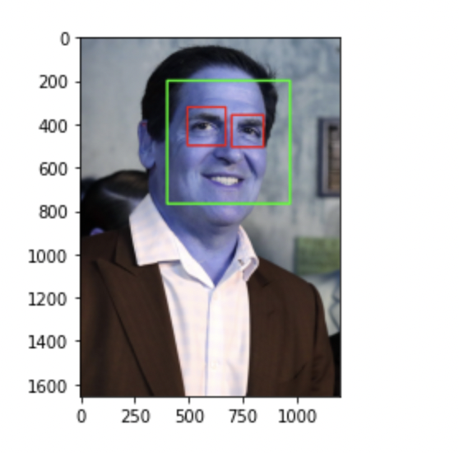

**We are interested in this below cropped image. So, we will crop all the images and capture it in cropped folder.**

So, for that we will create a cropped folder and insert all crop images in all 5 different shark tank cast folder.

* Now we will have cropped folder under datasets folder that contains cropped images
* Manually examine cropped folder and delete any unwanted images.

**Unwanted images means:**

**After this we will use wavelength transform:**

* Preprocessing: Use wavelet transform as a feature for training our model
* In wavelet transformed image, you can see edges clearly and that can give us clues on various facial features such as eyes, nose, lips etc.

**Let’s repeat our project flow:**

**Data Cleaning is done and now we will build our model.**

# We will use Grid Search to try out different models with different parameters. Goal is to come up with best model with best fine-tuned parameters.

So, from the above SVM and Logistic Regression is giving the good accuracy with 87%

**We will try it with super learner too:**

**Conclusion:**

I received more accuracy using hyper parameters:

* Logistic Regression: 87.73%
* SVM: 87.73